**Open Access publishing practice in Geochemistry: overview of current state and look to the future**

Olivier Pourret1*, Andrew Hursthouse2, Dasapta Erwin Irawan3 , Karen Johannesson4, Haiyan Liu5, Marc Poujol6 , Romain Tartèse7 , Antony van der Ent8, Eric D. van Hullebusch9, Oliver Wiche10

1UniLaSalle, AGHYLE, Beauvais, France

2School of Computing, Engineering & Physical Sciences, University of the West of Scotland, Paisley PA1 2BE, UK

3Faculty of Earth Sciences and Technology, Institut Teknologi Bandung, Bandung, Indonesia

4School of the Environment, University of Massachusetts Boston,   
Boston, USA

5School of Water Resources and Environmental Engineering, East China University of Technology, Nanchang 330013, PR China

6Université de Rennes, CNRS, Géosciences Rennes - UMR 6118, Rennes, France

7Department of Earth and Environmental Sciences, The University of Manchester, Manchester M13 9PL, UK

8Centre for Mined Land Rehabilitation, Sustainable Minerals Institute, The University of Queensland, Brisbane Qld 4072 Australia

9Université de Paris, Institut de physique du globe de Paris, CNRS, Paris, France

10Institute for Biosciences, Biology/Ecology Unit, TU Bergakademie Freiberg, Freiberg, Germany

*Corresponding author: [olivier.pourret@unilasalle.fr](mailto:olivier.pourret@unilasalle.fr)

**Abstract**

Open Access (OA) describes the free, unrestricted access to and re-use of research articles. Recently, a new wave of interest, debate, and practice surrounding OA publishing has emerged. In this paper, we provide a simple overview of the trends in OA practice in the broad field of geochemistry. Characteristics of the approach such as whether or not an article processing charge (APC) exists, what embargo periods or restrictions on self-archiving’ policies are in place, and whether or not the sharing of preprints is permitted are described. The majority of journals have self-archiving policies that allow authors to share their peer reviewed work via green OA without charge. There is no clear relationship between journal impact and APC. The journals with the highest APC are typically those of the major commercial publishers, rather than the geochemistry community themselves. The rise in OA publishing has potential impacts on the profiles of researchers and tends to devolve costs from organizations to individuals. Until the geochemistry community makes the decision to move away from journal-based evaluation criteria, it is likely that such high costs will continue to impose financial inequities upon research community. However, geochemists could more widely choose legal self-archiving as an equitable and sustainable way to progress communication of their research.

**Introduction**

The majority of published scientific papers are behind paywall, rendering them inaccessible to the majority of the public (Tennant et al., 2019). Since the end of the 1980s, members of the scholarly community have been making various cases for wider public accessibility to published research, referred to as Open Access (OA) (Suber, 2009). Scientific publishing is currently undergoing a major transition (Lajtha, 2019; Watts et al., 2019), with the change to OA representing a significant shift in the financial models of major publishers, opening up diversity in publishing routes and raising the issue of publishing ethics. It is critically important to ensure that scientists and their institutions do not have to pay more to read and publish papers than they do currently.

As with all other scientific disciplines, there is a strong imperative for the geochemistry community to ensure that the research it produces is widely accessible (Sparks, 2013; Chopin, 2018). Geochemistry as a discipline includes the study of the chemical composition of the Earth and other Solar System objects, and the geochemical processes that affect them (White, 2018; Holland and Turekian, 2013). Geochemical concepts and/or principles underlie many Earth and environmental processes, notably those relevant to human interaction with our planet from resource exploitation to public health. Since such themes have important societal implications, it is even more crucial to ensure widespread accessibility.

Open Access practices are increasing at a systemic level (Tennant et al., 2019). The movement around Plan S, a funder-led initiative launched in September 2018, aims to accelerate the full transition towards OA. These initiatives have opened up discussions about the ability of journals and research communities to appropriately and sustainably shift towards a dominantly OA model (Lajhta, 2019). Geochemistry, like other scientific disciplines, now has a range of publishing options available to authors operated by a range of universities, commercial publishers, and societies, forming a complex publishing landscape (Tennant et al., 2019).

As part of this transition, it is even more an imperative that individual research communities have get a better understanding of the academic publishing landscape, and the options available to researchers. Many of the professional societies active in this aspect are currently evaluating their publishing strategies and models, and some are considering an increased role for OA publication in their journals. Here we provide an overview and analysis of the current OA practices in “geochemistry” journals. This evaluation an intention to support further debate, raise awareness and support decision making processes for the future development of the geochemistry community (Chopin, 2018).

**Methods**

We constructed a list of 56 journals in which geochemistry research is regularly published based on the Scopus, Web of Science, Scimago and Sherpa/RoMEO databases. This list only includes discipline-specific journals (where the word ‘geochemistry’ appears in the aims and scope of the journal). Interdisciplinary “mega-journals”, interdisciplinary environmental journals and regional journals were excluded, acknowledging the publication of geochemically focused studies in these journals. The full dataset, provided in Supplementary Information, was based on a first review in July 2019 and updated in November 2019 to ensure current practice was captured. Data included:

Journal name;

Year of first publication;

Journal policy on:

* sharing of preprints (version of a research paper typically shared prior to peer review and publication in a journal);
* sharing of postprints (version of a research paper subsequent to peer review and, thus, acceptance, but before any type-setting or copy-editing by the publisher);
* Presence or absence of an embargo period;
* Sharing of the publisher version (known as VOR, Version of Record of scholarly research paper, after undergoing formatting by the publisher);
* option for gold OA exists (*i.e.,* instant availability at the point of journal publication; including hybrid OA);

- Article processing charge (APC) for the gold OA option (zero denotes diamond OA);

- Sherpa/RoMEO (<http://www.sherpa.ac.uk/romeoinfo.html>) color status ([green](http://sherpa.ac.uk/romeo/browse.php?colour=green&la=en&fIDnum=%7C,&mode=simple&version=): preprints and postprints can be archived; [blue](http://sherpa.ac.uk/romeo/browse.php?colour=blue&la=en&fIDnum=%7C,&mode=simple&version=): postprints can be archived; [yellow](http://sherpa.ac.uk/romeo/browse.php?colour=yellow&la=en&fIDnum=%7C,&mode=simple&version=): preprints can be archived; [white](http://sherpa.ac.uk/romeo/browse.php?colour=white&la=en&fIDnum=%7C,&mode=simple&version=): archiving not formally supported);

- Journal impact factor in 2018;

- Name of publisher.

It should be noted that Sherpa/RoMEO colour status is not related to the OA type (*i.e.* gold, green…). For APC data, an average number of ten printed pages was considered for publishers that use a page-based fee. Prices were converted to US$ when necessary.

**Results and discussion**

# Historically, geochemists have published much of their work in journals edited by geochemistry-related professional societies (Holland and Turekian, 2013). The first issue of *Geochimica et Cosmochimica Acta* appeared in 1950. The *Geochemical Society* (GS) was founded in 1955 and adopted *Geochimica et Cosmochimica Acta* as its official publication in 1957. The *International Association of Geochemistry and Cosmochemistry* (IAGC) was founded in 1966, and its journal, *Applied Geochemistry*, began publication in 1986. *Society for Environmental Geochemistry and Health* was established in 1971 and *Environmental Geochemistry and Health* became the official journal in 1981. *Chemical Geology* became the journal of the *European Association of Geochemistry* (EAG), which was founded in 1995. Geochemistry has become a major force in the *Geological Society of America* and in the *American Geophysical Union* (AGU) with titles like *Geochemistry, Geophysics, Geosystems*. The titles listed above were originally owned by professional societies that used to work with small editing companies. Most of these small companies were then progressively acquired by major publishing companies (*e.g. Geochimica et Cosmochimica Acta* was historically published by Pergamon, but was purchased by Elsevier in 1991). In the meanwhile, European Geosciences Union (EGU) use the OA business model with Copernicus but nine of these titles focus on geochemistry exclusively until 2019.

The journals analyzed here mostly have a gold OA policy (49/56; 88%). In the case of geochemistry this generally translates to an “author pays” model (45/49; 92%) (Lajtha, 2019). Indeed, only five of the journals included in the database do not have APC. These journals comprise two community-led initiatives from within professional societies (EAG and EGU), a journal published by a university (Sapienza Università di Roma) and a journal published by Elsevier and funded by China University of Geosciences (Beijing) and Peking University.

In the list of journals where OA is available, 45 apply an APC and 7 journals do not have a gold OA option. The APCs range from 4,000 US$ for journals such as *ACS Earth and Space Chemistry* or *Elements* (owned by the American Chemical Society and jointly published by 17 participating societies, including the *EAG* and the GS) to less than 1,000 US$ for EGU journals published by Copernicus (Figure 1). Amongst journals that charge APC, most of them charge between 2,500 US$ and 4,000 US$ per article (28) (Figure 1), dominated by major commercial publishers, (Elsevier, Springer Nature, and Wiley). The general state of the scholarly publishing industry can be described as an oligopoly, with a few major actors dominating the scene (Larivière et al., 2015). Elsevier and SpringerNature publish the highest number of geochemistry journals (13 and 12, respectively), followed by Wiley (5). Together, this represents around 55% of the total number of geochemistry journals. The next largest publishers in terms of number of journals are the EAG (3 if *Elements* is included*,* which is jointly published by 17 societies) and Copernicus (4), followed by Cambridge University Press (2), Schweizerbart (2), MDPI (2), Hindawi (2), and ten other publishers (1 each).

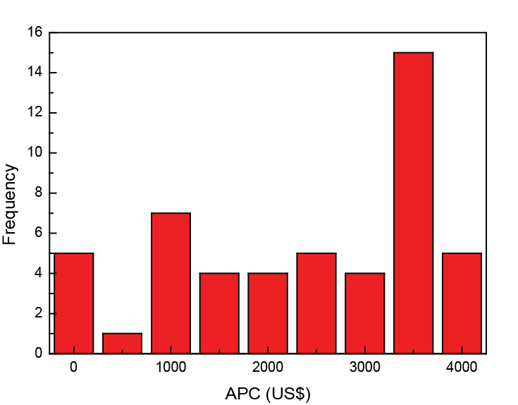

**Figure 1** APC distribution for all journals that have a gold OA option.

The majority (84%) of journals in our database allow authors to share preprints of their articles (47/56). Only 4 journals do not allow sharing article preprints (8%), all of which being professional society-based journals. Five journals do not have an explicit preprint policy (6%). For postprints, the situation is broadly similar. Forty-seven journals allow authors to share postprints (84%), and only 4 explicitly prohibit postprint sharing (8%). Five journals do not have a clear postprint sharing policy (8%). The 4 journals that prohibit sharing of postprints are the same that prohibit sharing of preprints. Journals from the large commercial publishers (Elsevier, Springer Nature, Wiley) and from most professional societies allow sharing of postprints. Earth scientists, including geochemists, are in the top group to pursue green road to OA (Bjork et *al.*, 2004). MDPI, which is a purely OA publisher, publishes a few journals in Earth Sciences but does not have dedicated geochemical titles, although *Geosciences* has a Geochemistry section. Hindawi, another purely OA publisher, manages *Geofluids* and a geochemistry section in *Journal of Chemistry* (after withdrawing the *Journal of Geochemistry*). The AGU publishes several newly-established journals in OA and promotes the green road to OA in the geochemistry field via a number of well-established journals (e.g., *Geochemistry, Geophysics, Geosystems*, *Journal of Geophysical Research-Solid Earth*). Authors in AGU subscription-based journals are granted general permission to deposit the final published citable VOR of the article six months after official publication (Van der Hilst and Hanson, 2013). Springer's portfolio of OA journals, Springer Open, also includes a number of geochemistry titles (including *Aquatic Geochemistry*, *Biogeochemistry* and *Environmental Geochemistry and Health*). The first transitions from subscription-based to full-OA journals have already taken place. In the 2000s, *Geochemical Transactions* moved toward full OA (Schoonen et *al.*, 2006). In 2012, the EAG released its new title *Geochemical Perspectives*, which was followed in 2015 by *Geochemical Perspectives Letters.*  Finally, Elsevier launched its title *Results in Geochemistry* in the autumn of 2019.

Overall, 49/56 journals (88%) have an entry in SHERPA/RoMEO, among which 37 are “green”, 2 “blue”, 4 “yellow”, 6 “white” (Figure 2).

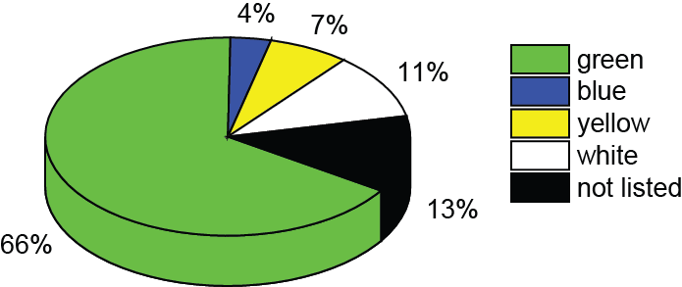

**Figure 2** SHERPA/RoMEO colors. [Green](http://sherpa.ac.uk/romeo/browse.php?colour=green&la=en&fIDnum=%7C,&mode=simple&version=) indicates that preprints and postprints can be archived, [blue](http://sherpa.ac.uk/romeo/browse.php?colour=blue&la=en&fIDnum=%7C,&mode=simple&version=) that postprints can be archived, [yellow](http://sherpa.ac.uk/romeo/browse.php?colour=yellow&la=en&fIDnum=%7C,&mode=simple&version=) that preprints can be archived, and [white](http://sherpa.ac.uk/romeo/browse.php?colour=white&la=en&fIDnum=%7C,&mode=simple&version=) that archiving is not formally supported.

Most geochemistry journals have a journal impact factor (JIF) between 2 and 5 (Figure 3). Outliers to this range include monographs (*Geochemical Perspectives*), book series (*Reviews in Mineralogy & Geochemistry*), as well as review journals (*Elements*), which tend to inherently accrue more citations and are often considered to be of higher impact. The relationship between JIF and APCs does not show any evident correlation (Figure 3). Only three journals with a JIF above 4 do not charge an APC, *Geochemical Perspective, Geochemical Perspective Letters*, and *Geosciences Frontiers*.

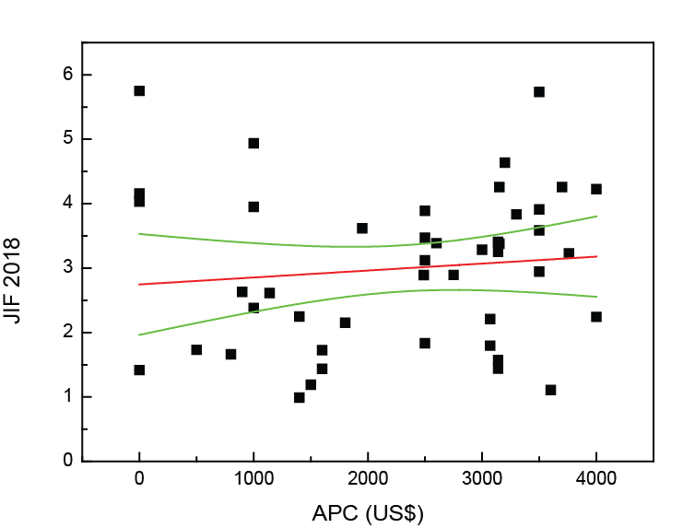

**Figure 3** JIF as a function of APC (Pearson’s r=0.1079; red line corresponds to the linear fit, whereas green lines correspond to the 95% intervals.

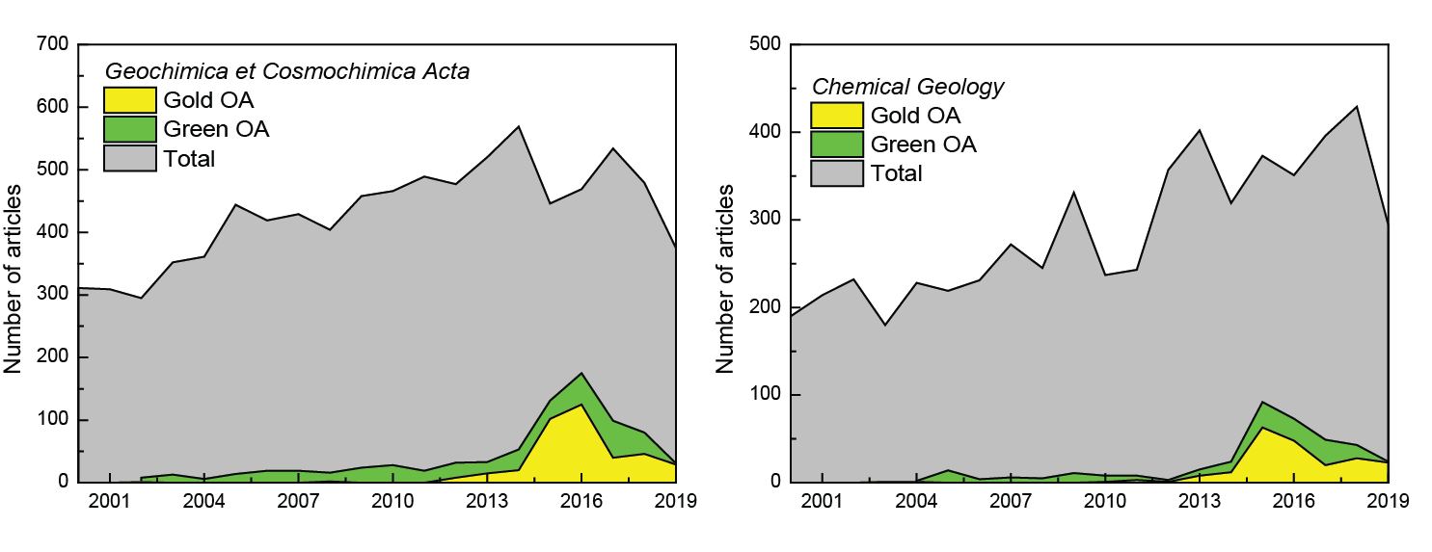

**Figure 4** Evolution of OA distribution for articles published between 2000 and 2019* in (a) *Geochimica et Cosmochimica Acta* and (b) *Chemical Geology* (data accessed July 2019 from Scopus for gold OA and total, and @unpaywall for green OA). *year 2019 is incomplete.

In 2018, among tophybrid (with APC) and historical journals with APC, only 9% of *Chemical Geology* and 14% of *Geochimica et Cosmochimica Acta* papers, respectively, were available as gold OA. The distribution of articles published in *Geochimica et Cosmochimica Acta* show that their country of origin are 56% from the USA, 11% from Germany, 10% from France, and 10% from the UK. Gold OA articles originate 66% from the USA, 37% from the UK, and 16% from France. In comparison, 33% of the articles published in *Chemical Geology* originate from the USA, 16% from France, and 14% from Germany. For gold OA articles published in *Chemical Geology*, 57% originate from the USA, 27% from the UK, and 20% from Germany. Green OA is mostly available on dedicated repositories such as *HAL* (*i.e.* French repository <https://hal.archives-ouvertes.fr>) where 42% of green OA articles for *Geochimica et Cosmochimica Acta* and 23% of green OA articles for *Chemical Geology* are archived. Gold OA publishing peaked in 2015 and 2016 for *Geochimica et Cosmochimica Acta* (23% and 27%, respectively) and for *Chemical Geology* (17% and 14%, respectively). Similarly, green OA publishing peaked between 2015 and 2017 in *Geochimica and Cosmochimica Acta* (7%, 11%, and 11%, respectively)and *Chemical Geology* (8%, 7%, and 7%, respectively) (Figure 4).

As scientific publishing continues to transition from the traditional pay-walled model to OA, it is likely that increasingly individual researchers will face difficulties addressing the APC system, regardless of any potential waiver or discount systems in place. Thus, the APC-driven elements of OA generally restrains journal choice available for those individuals who want to, or have to, publish OA articles, but have restricted funding. In many cases, one of the only options is to publish their research in a high impact journal without paying the APC and place their paper behind a paywall. Overall, the APC-dominated philosophy has created a complex system around OA. This scheme seems to broadly the research community into two groups of those that can afford to publish in OA journals, and especially in those that charge high APC, and those that do not benefit from such financial resource and are forced to publish behind the paywall. It would be interesting for future research to investigate the impact that APC-related constraints have had on publication choices for researchers, and the potential impact this can have on the visibility and re-use of geochemical research.

Eventually, there is a clear role for self-archiving of peer reviewed accepted manuscripts (postprint), the green way, in parallel to traditional journal publication. Indeed in some countries the policy of making research available to the wider public (the tax payer, ultimately funding the research) has essentially established institutional archives to do this. The Green OA approach is cost-free for authors and to pursue green OA, numerous platforms are available such as institutional repositories and collaborative tools such as EarthArXiv (<https://eartharxiv.org/>) and Earth and Space Sciences Open Archive (https://essoar.org/) for preprints. Preprint model is unfortunately still confidential in geochemistry. In some areas (eg Indonesia), preprint would potentially interfere with paper publishing process in journal, since most journal editors still think preprint as prior publication. Another area of concern is that the current APC model has an additional restriction on research from developing countries, where the fees for OA are beyond reach, driving to lower or no cost options of the “predatory journals” (Beall, 2016). The proliferation in opportunities to publish scientific research as OA articles in these journals where lack of support from scientific societies and un-validated review processes and “for profit” approach with little apparent consideration of what is published. This questions the long term future of peer review and the ethics of publishing. We acknowledge that there is a good level of debate on this topic between professional and learned societies and academic publishers. We encourage the geochemical community to be active and engage in the debate and actions, prioritizing clear, transparent and robust peer review and visibility of our work.

**Concluding remarks**

In the context of the rapid evolution of scientific publishing models, it seems necessary to draw attention to the situation of hybrid journals, which include the majority of traditional historical journals in geochemistry. Plan S (<https://www.coalition-s.org/>, among others) recommends supporting fully open access publications and, therefore, excludes hybrid journals. It formally discourages researchers and institutions from having to pay additional fees in a subscription-based journal and asks us not to support a model that introduces “double-dipping”. It is indeed possible to publish in a hybrid journal without paying APC and to disseminate its manuscript in open archives on a repository. On the website of the journal, the article will be accessible only to subscribers, and it will be accessible to all on the open archive (the green way). We also need to look at journal management in general in the southern part of the globe, where most of the journals are OA with no fee for the authors. The operational of the journals is still built upon the scientific community with low to moderate size institutional funding, e.g., Latin America, SE Asia. Ironically, scientists from those two regions commonly think that the western OA (with high APC) model is the best in the world. Most of them also believe that such a model should also be applied to their countries as well, although Suber (2009) and some other international and local OA activitists have continuously mentioned that OA should not be associated with the APC model.

**Acknowledgments**

The authors would like to thank Heather Piwowar for providing Green Open Access data available via @unpaywall.

**References**

Beall, J., 2016. Medical publishing and the threat of predatory journals. International Journal of Women's Dermatology, 2(4): 115-116.

Björk, B.-C., Laakso, M., Welling, P., Paetau, P., 2014. Anatomy of green open access. Journal of the Association for Information Science and Technology, 65(2): 237-250.

Chopin, C., 2018. The credibility of scientific writing: An appeal for responsibility. Elements, 14(2): 79.

Holland, H.D., Turekian, K.K., 2013. Executive Editor's Foreword to the Second Edition. Treatise on Geochemistry: Second Edition: xvii-xix.

Lajtha, K., 2019. Publishing scientific research in open access, hybrid, or paywall journals: what model serves all authors and all readers? Biogeochemistry, 144: 229-231.

Larivière, V., Haustein, S., Mongeon, P., 2015. The Oligopoly of Academic Publishers in the Digital Era. PLOS ONE, 10(6): e0127502.

Schoonen, M.A.A., Anderson, K.B., Wood, S.A., 2006. Moving Geochemical Transactions forward as an open access journal. Geochemical Transactions, 7: 1-1.

Sparks, R.S.J., 2013. Opportunities for Innovative Publishing in the Electronic Age? Eos, Transactions American Geophysical Union, 94(12): 116-116.

Suber, P. 2009. Open access? *Nature Geoscience* 2, 155.

Tennant, J.P., Crane, H., Crick, T., Davila, J., Enkhbayar, A., Havemann, J., Kramer, B., Martin, R., Masuzzo, P., Nobes, A., Rice, C., Rivera-López, B., Ross-Hellauer, T., Sattler, S., Thacker, P.D., Vanholsbeeck, M., 2019. Ten Hot Topics around Scholarly Publishing. Publications, 7(2): 34.

Van Der Hilst, R., Hanson, B., 2013. Update on AGU Publishing: A Focus on Open Access. Eos, Transactions American Geophysical Union, 94(39): 345-345.

Watts, M.J., An, T., Argyraki, A., Arhin, E., Brown, A., Button, M., Entwistle, J.A., Finkelman, R., Gibson, G., Humphrey, O.S., Huo, X., Hursthouse, A.S., Marinho-Reis, A.P., Maseka, K., Middleton, D.R.S., Morton-Bermea, O., Nazarpour, A., Olatunji, A.S., Osano, O., Potgieter-Vermaak, S., Saini, S., Stewart, A., Tarek, M., Torrance, K., Wong, M.H., Yamaguchi, K.E., Zhang, C., Zia, M., 2019. The Society for Environmental Geochemistry and Health (SEGH): building for the future. Environmental Geochemistry and Health.

White, W.M., 2018. Geochemistry, Encyclopedia of Earth Sciences Series, pp. 561-570.